Commendation & Awards
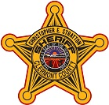

It is the policy of the Clermont County Sheriff’s Office to recognize outstanding employee performance through the use of formal commendations. Expression of gratitude for services or actions by employees is greatly appreciated. Letter recognizing employees or citizens for their actions are encouraged and may be forwarded to the Sheriff at:

4470 State Route 222 Batavia, OH 45103
Or
Via email: http://www.clermontsheriff.org/contact-us/

An awards panel is used to determine the appropriate commendation

Examples include:
Letter of Recognition
Letter of Appreciation
Exceptional Service
Commendation Award

